Adrianna Fierro

Civil War Era

Music Lesson -Focus on Abolition and Slave songs

New York State Core Curriculum: Unit Six: Division and Reunion, Part one: I. Underlying Causes of the Civil War.

NYS Standard(s): Standard 1: History of the United States and New York. Standard 5: Civics, Citizenship and Government

NCSS Standard(s): Theme 2: Time, Continuity and Change. Theme 3: People, Places and Environment. Theme 5: Individuals, Groups and Institutions. Theme 6: Power, Authority and Governance.

Focus question: What were the arguments for emancipation of African American slaves?

Learning Objectives:

Students will be able to examine and discuss the role that music played in the abolitionist movement so that they can understand the various political and social views of the time.

Students will be able to examine and highlight the role that music (songs) played in the Underground Railroad so that they can understand the importance of music as a communication tool of the time.

Students will be able to articulate empathy for African Americans held in bondage so that they can better understand the struggles slaves endured to attain their freedom.

Materials:

# “Hymn 17” lyrics from -Anti-slavery Melodies: *For the Friends of Freedom* edited by Jairus Lincoln also available online at <http://en.wikipedia.org/wiki/My_Country,_'Tis_of_Thee#cite_note-5>

“Wade in the Water” song lyrics and audio link, unknown original author, accessed from <http://pathways.thinkport.org/secrets/music2.cfm>

“Follow the Drinking Gourd” song lyrics and audio link, unknown original author, accessed at <http://www.eduplace.com/kids/socsci/ca/books/bkc/sources/bkc_template.jsp?name=spiritual>

“Swing Low, Sweet Chariot” song lyrics and audio link, written by [Wallace Willis](http://en.wikipedia.org/wiki/Wallace_Willis), accessed at <http://en.wikipedia.org/wiki/Swing_Low,_Sweet_Chariot>

Computer with internet access for audio of songs and short video segment of Wade in the Water

on <http://www.youtube.com/watch?v=ZXqMQfpNSes>

Background:

African American songs sometimes referred to as spirituals, usually with a Christian religious theme, were originally sung a cappella and were antecedents of the blues. The terms Negro spiritual, and African-American spiritual, jubilee, and African-American folk songs are all synonymous. They were an expression of spiritual devotion and a yearning for freedom from bondage. The importance of song and music was for so long overlooked by plantation owners. Slaves used songs to convey hidden codes, and to help boost morale of their fellow workers.

Initially, slaves used song and music to boost the overall happiness of the people they worked with. Sometimes they were a means of releasing pent up emotions and expressing sorrow. During times of difficult labor, slaves would break out in a song to pass the time, and lift their spirits as they sometimes provided comfort and eased the boredom of daily tasks. Slaves would often sing songs that praised the lord, or asked the lord for help and guidance.

Additionally, slaves actually put codes into songs to relay secret messages among their slave community. Today, these songs are well known because of the amount of specific information coded within its lyrics.

Anticipatory Set:

Instructor will begin class by asking students to do a quick write of what they remember from last class in their notebook (provide approximately two to five minutes). The instructor will then lead class discussion on the importance of and goals of African American spirituals and then ask students to complete the first column of the provided KWL chart. This five to eight minute review will provide students with a refresher of the topic and stimulate memory and background knowledge.

Activity:

The instructor will distribute the lyrics of the songs and the graphic organizer. Students will be grouped into pairs (higher ability with lower ability) to analyze the documents. The instructor will play the music clips for students, pausing between each song to discuss purpose, leadership, cultural and political reasoning, etc. The teacher will move about the room to ensure groups are completing assignment and to assist groups that are experiencing difficulty and require additional help. Students will complete the KWL chart in to wrap up activity.

Theories and/or research based practices to construct the lesson

The lesson includes print, visual, and audio sources to accommodate all levels and types of learners. There is also a graphic organizer to help students brainstorm and structure their thinking so they can make connections and gain understanding of the content, enabling them to write coherently about the topic. The teacher will be physically monitoring all of the students by walking about the room and always be in close physical proximity to all of the students. This is helpful to visually monitor which students may require assistance by quick review of their work, providing corrective feedback when needed. The instructor will check for understanding to promote comprehension through a series of questions. Homework will be assigned for continued review and practice of material. “Homework assignments provide the time and experience students need to develop study habits that support learning. They experience the results of their effort as well as the ability to cope with mistakes and difficulty” (Bempechat, 2004).

Informal Assessment:

The instructor will visually check to see if students are synthesizing information from multiple sources to understand main ideas in order to support their written claims.

Formal Assessment:

Students will complete the graphic organizer and complete an exit ticket with five questions on the information from the activity.

Homework:

Students will write a paragraph, consisting of three or more sentences, detailing what they learned from the activity.

[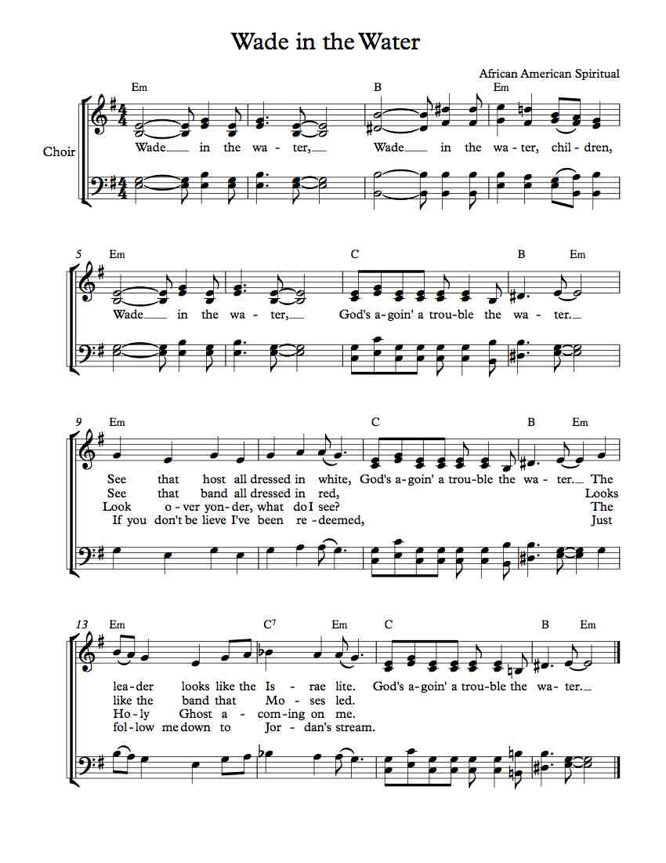](http://www.google.com/url?sa=i&rct=j&q=&esrc=s&source=images&cd=&cad=rja&uact=8&docid=o-flbD-YI4VblM&tbnid=uoL3NYStlxZfDM:&ved=0CAUQjRw&url=http%3A%2F%2Fmichaelkravchuk.com%2Ffree-choir-sheet-music-wade-water%2F&ei=l1ThU4niHI3e7AahpYDgBg&psig=AFQjCNHTejJl2nt07Q_8tkVk3HVdW9LbNQ&ust=1407362421517395)

<http://www.sheetmusicdirect.com/se/ID_No/17771/Product.aspx>

**“Wade in the Water”**

**(Chorus)  
Wade in the water.  
Wade in the water, children.  
Wade in the water.  
God's gonna trouble the water.**

**Well, who are these children all dressed in red?  
God's a-gonna trouble the water  
Must be the children that Moses led  
God's a-gonna trouble the water.**

**Chorus**

**Who's that young girl dressed in white   
Wade in the Water   
Must be the Children of Israelites   
God's gonna trouble the Water.**

**Chorus**

**Jordan's water is chilly and cold.  
God's gonna trouble the water.  
It chills the body, but not the soul.  
God's gonna trouble the water.**

**Chorus**

**If you get there before I do.  
God's gonna trouble the water.  
Tell all of my friends I'm coming too.  
God's gonna trouble the water.**

**Chorus**

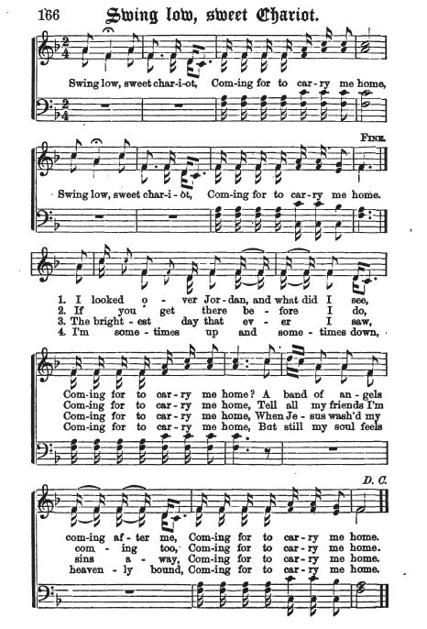

<http://en.wikipedia.org/wiki/Swing_Low,_Sweet_Chariot#mediaviewer/File:SwingLowSweetChariot1873.jpg>

**“Hymn 17” from Anti-slavery Melodies: *For the Friends of Freedom***

My country, 'tis of thee,

Stronghold of slavery, of thee I sing;

Land where my fathers died,

Where men man’s rights deride,

From every mountainside thy deeds shall ring!

My native country, thee,

Where all men are born free, if white’s their skin;

I love thy hills and dales,

Thy mounts and pleasant vales;

But hate thy negro sales, as foulest sin.

Let wailing swell the breeze,

And ring from all the trees the black man’s wrong;

Let every tongue awake;

Let bond and free partake;

Let rocks their silence break, the sound prolong.

Our father’s God! to thee,

Author of Liberty, to thee we sing;

Soon may our land be bright,

With holy freedom’s right,

Protect us by thy might, Great God, our King.

It comes, the joyful day,

When tyranny’s proud sway, stern as the grave,

Shall to the ground be hurl’d,

And freedom’s flag, unfurl’d,

Shall wave throughout the world, O’er every slave.

Trump of glad jubilee!

Echo o’er land and sea freedom for all.

Let the glad tidings fly,

And every tribe reply,

“Glory to God on high,” at Slavery’s fall.

**Follow the Drinking Gourd**

Follow the drinking gourd!   
Follow the drinking gourd.   
For the old man is a–waiting for to carry you to freedom   
If you follow the drinking gourd.   
  
When the sun comes back and the first quail calls,   
Follow the drinking gourd.   
For the old man is a–waiting for to carry you to freedom   
If you follow the drinking gourd.   
  
The riverbank makes a very good road,   
The dead trees will show you the way.   
Left foot, peg foot, traveling on,   
Follow the drinking gourd.   
  
The river ends between two hills,   
Follow the drinking gourd.   
There's another river on the other side,   
Follow the drinking gourd.   
  
When the great big river meets the little river,   
Follow the drinking gourd.   
For the old man is a–waiting for to carry you to freedom   
If you follow the drinking gourd.